**Exercise:** Below is a word scramble of important terms that are in some way connected to inelastic x-ray scattering (IXS). Using the clues provided, fill in the correct unscrambled word. All letters are in lower case. For terms that involve two words, each scrambled portion contains only letters used in that word belonging to that portion (ex: “ienstialc sacreinttg” ➝ “inelastic scattering”).

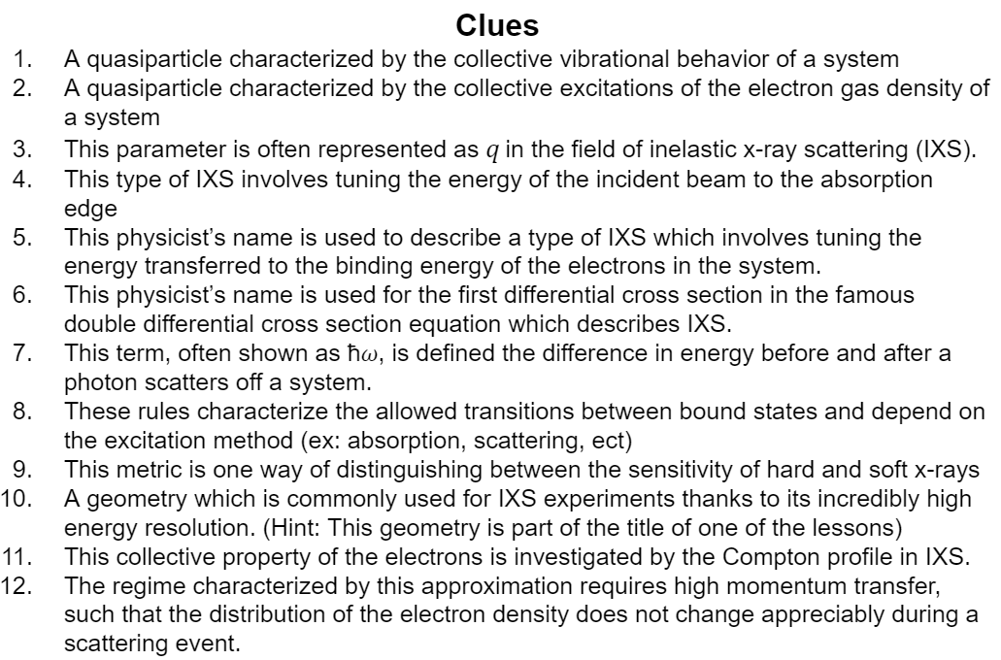

**Suggested Reading:** *Electron Dynamics by Inelastic X-Ray Scattering* [2], High resolution 1s core hole X-ray spectroscopy in 3d transition metal complexes—electronic and structural information [5]

**Vocabulary Words:**

**Inelastic X-ray Scattering (IXS):** A process in which an incident x-ray photon interacts with an atom and experiences a change in energy and (almost always) a change in momentum. This energy and momentum are transferred to the system which the x-ray scatters off of. Spectroscopy based on IXS relies on measuring this change in momentum and energy to gain a wealth of information about the structure of the system being scattered off of.

**X-ray Raman Scattering (XRS):** A specific type of IXS spectroscopy which provides information similar to XAS, where the energy transferred to the system is tuned to the binding energy of the electrons.

1. Introduction and Compton Scattering
2. Consider the inelastic scattering of a photon which has some wave vector, energy , and polarization (unit vector) . The initial and final states are denoted with subscripts *i* and *f* respectively. The momentum change of the photon (and subsequently the momentum transferred to the electrons) is . If the incident x-ray has high energy, then show how the momentum transfer amplitude can be approximated as

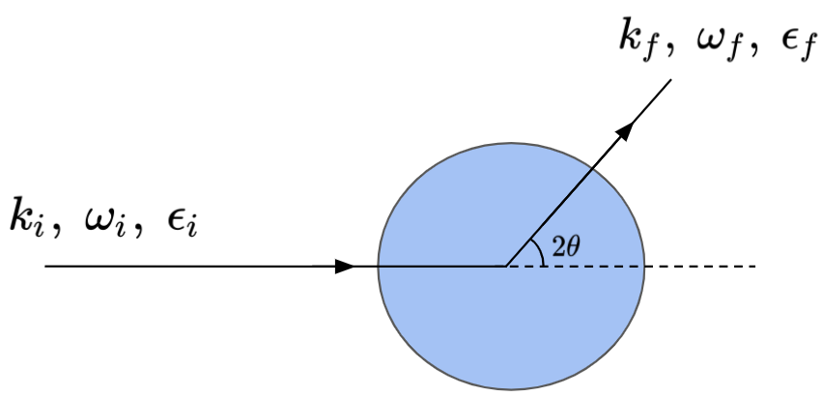

Solution: For a high energy x-ray, the change in the wave vector is small such that meaning that

\vec{q} = \; \left[ k_i-k_f \cos(2\theta), \; k_f \sin(2\theta) \right] \\
|\vec{q}| = \sqrt{k_i^2 -2k_i k_f \cos(2\theta) + k_f^2 \cos^2(2\theta) +k_f^2 sin^2(2\theta)} \\
|\vec{q}| = \sqrt{k_i^2 + k_f^2 - 2k_i k_f \cos(2\theta) } \quad k_f \approx k_i \\
|\vec{q}| = \sqrt{2k_i^2 - 2k_i^2 \cos(2\theta)} = 2k_i \sqrt{\frac{1-cos(2\theta)}{2}} = 2k_i sin(\theta)

1. Using the same diagram as the previous problem, now assume that the photon scatters off an electron which has some initial momentum . Write an expression for the energy of the electron after the scattering event. (Hint: Recall that )

Solution:

Atomic units, i.e. ħ=1

\omega = \frac{(\boldsymbol{p}  +\boldsymbol{q}) \, \cdot \, (\boldsymbol{p}  +\boldsymbol{q})}{2m} - \frac{\boldsymbol{p} \, \cdot \,\boldsymbol{p}}{2m} =  \frac{q^2}{2m} + \frac{ \boldsymbol{p} \, \cdot \, \boldsymbol{q}}{m}


1. In general, there are multiple different regimes of inelastic scattering. However, for this section we are particularly interested in the regime where the energy of the incident photon is far from the binding energies of the electrons in the sample. The non-relativistic double differential cross section describing this region is given by

**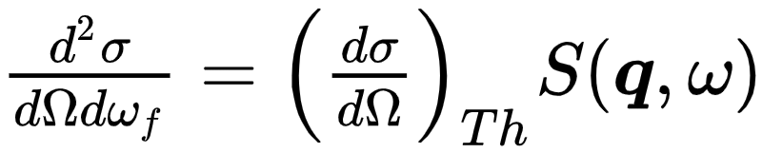**

**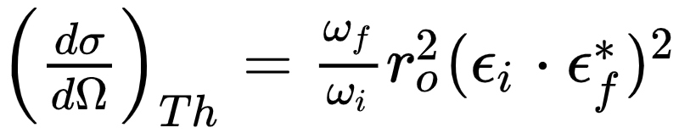**

**S(\boldsymbol{q}, \omega) = \sum_f  \left| <f|\sum_j exp(i\boldsymbol{q} \, \cdot \, \boldsymbol{r}_j )|i> \right|^2 \delta(E_f-E_i-\omega)**

Where 𝛺 is the detected solid angle, is the Thomson differential cross section, **r**j is the position operator of the jth electron,and S(**q**, 𝜔) is the dynamic structure factor. The Thomson differential cross section characterizes the physical probe that we using to investigate the system, but S(**q**, 𝜔) is the component that contains the physics we are particularly interested in.

1. In the impulse approximation, we assume that the scattering process occurs very quickly so that we are explicitly probing the ground state. This allows the the dynamical structure factor to be rewritten as

**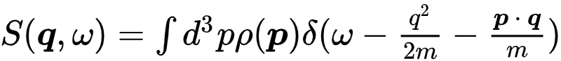**

(See the derivation in Eisenberger and Platzman [6] for more information) where is the electronic momentum distribution. By assuming that the scattering process occurs quickly, what assumption are we making about the potential that the scattered electron experiences?

We assume that the electron experiences a constant potential, meaning that the energy of the electron in the initial and final states is measured relative to the constant instantaneous potential. By saying that the scattering process occurs quickly, we are implying that the system does not have time to rearrange itself, keeping the potential the electron experiences constant.

1. So far we have not considered the multiple-electron case, but from your intuition about the scattering process we have described with the impulse approximation (scattering process involving only a single electron), what constraint could we place on that momentum transfer that would ensure our model is still valid?

The inverse of the momentum transfer should be much smaller than the average interparticle spacing. This ensures that the scattering process stays dependent on the momentum transferred to a single electron and not the collective behavior of the scattering system.

1. Note that in the expression we gave earlier for the dynamical structure factor in the impulse approximation the delta function ensured the relationship between the energy transfer 𝜔, the electron momentum , and the transferred momentum that we derived in question B.

\omega = \frac{(\boldsymbol{p}  +\boldsymbol{q}) \, \cdot \, (\boldsymbol{p}  +\boldsymbol{q})}{2m} - \frac{\boldsymbol{p} \, \cdot \,\boldsymbol{p}}{2m} =  \frac{q^2}{2m} + \frac{ \boldsymbol{p} \, \cdot \, \boldsymbol{q}}{m}


This delta function can be rewritten in terms of the variable which is the projection of the electron momentum vector onto the momentum transfer vector.

**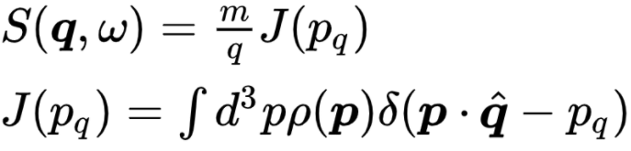**

defines the lineshape of the dynamical structure factor and is known as the Compton profile. We can see that it depends directly on the electron momentum distribution . gives the average number of electrons with momentum-projection .

Let’s consider the example of a non-interacting gas of fermions at zero temperature. The momentum distribution for this is a simple sphere in k-space with a radius of the Fermi momentum. The Compton profile integral will be a sum over all the states which have a projection of A visual representation of the fermi sphere is provided below [**CITATION NEEDED**]. Find an expression for the Compton profile for the non-interacting Fermi gas at zero temperature and plot it in the space provided. What shape does have?

**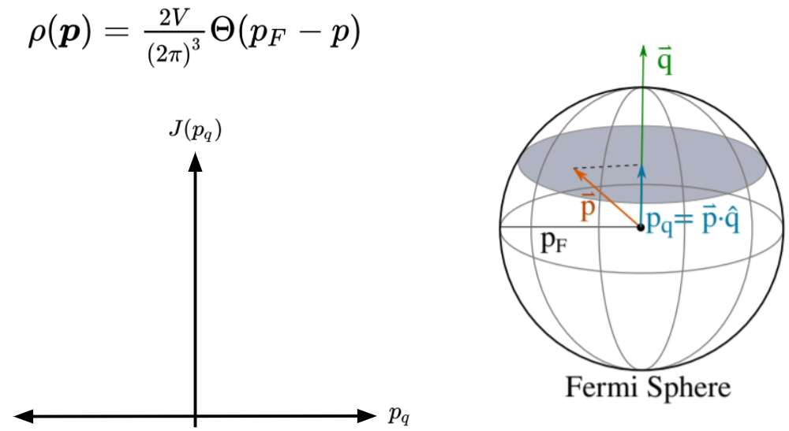**

1. At this point we have hopefully developed a sufficient enough understanding of the behavior of the dynamical structure factor S(**q**, 𝜔) to be able to qualitatively explain some trends in experimental data. Below is a plot of S(**q**, 𝜔) from an inelastic scattering experiment for polycrystalline Be [**CITATION NEEDED**].

**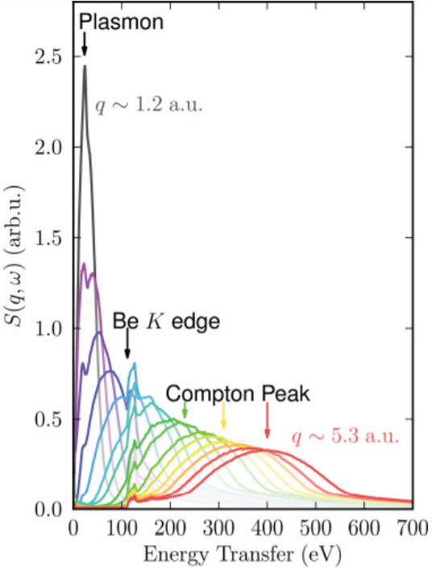**

1. Why does the Compton peak shift to higher energies with greater momentum transfer q? (Hint: Consider the conditions imposed by the delta function)
2. Why does the Compton peak become broader with momentum transfer? (Hint: Consider the conditions imposed by the delta function)
3. Is the impulse approximation valid for the case where in this system? Explain.
4. Some of the first experiments using x-ray inelastic scattering were done in the Compton limit, where high momentum and high energy transfer were used to get information about the distribution of the electron density in momentum space [2]. In general terms, what was the goal of these experiments, what were they testing? Why was this significant? (Hint: For more information, see the the 1929 paper by Du Mond [5])

By looking at the width of the Compton profile in the IXS spectra, the Fermi statistics of the system were probed. This confirmed that the classical distribution of electron momentums predicted by Maxwell-Boltzmann statistics were indeed an insufficient description of quantum systems.

1. X-ray Raman Scattering: Instead of being absorbed, an x-ray can scatter off the electron density surrounding an atom and loose part of its energy. When sufficient energy is lost, this process can excite a core electron in the atom. This process is known as x-ray Raman scattering (XRS).
2. Consider the case of soft x-ray absorption, such as for the K edges of light elements or L and M edges of transition metals or even the O and N edges of lanthanides where the energy range of interest is roughly between 10 eV to 1000 eV. From an experimental standpoint, what complications does this present?

The penetration depth of x-rays in this energy range is quite small, meaning that you are highly sensitive to surface effects and that your sample must be incredibly thin (if doing transmission). Additionally, samples need to be held under vacuum conditions so as to preserve as much of the incident flux as possible. This can significantly limit the types of samples that can be studied.

1. As we have established before, the dynamical structure factor S(**q**, 𝜔) is given as

S(\boldsymbol{q}, \omega) = \sum_f  \left| <f|\sum_j exp(i\boldsymbol{q} \, \cdot \, \boldsymbol{r}_j )|i> \right|^2 \delta(E_f-E_i-\omega)

In the space below, rewrite this equation in the limit of where is the radius of the core orbital, otherwise known as the dipole limit.

**Solution:**

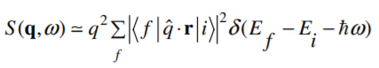

What does this imply about the regime that XRS is probing? How is this analogous to standard XAS? (Hint: Consider the form of the x-ray absorption coefficient that we derived in the Theory (selection rules) section.)

XRS is probing the unoccupied density of states, similar to XAS, through dipole allowed transitions between initial and final states. Note, this is only valid within the limit of the dipole approximation.

1. Consider the situation in which is not small (meaning the dipole approximation is no longer valid), but the energy transfer is still approximately equal to the binding energy What new sensitivity does this provide? Consider the expression you derived at the beginning of this section which related the momentum transferred to the incident wave vector and the scattering angle, . Explain how, from an experimental perspective, this makes it very easy to access this new sensitivity.

XRS can also probe quadrupole transitions by looking at the region in which is not small, meaning that the dipole approximation is no longer valid. This is relatively easy in that you only have to shift the scattering angle 𝜃 which to the desired range, as described by Experimentally, this means that you only have to shift the scattering angle at which you place your detector, without changing anything else fundamental about the experimental setup.

1. Depicted below is the experimental setup for the lower energy resolution inelastic x-ray scattering (LERIX) spectrometer at the Advanced Photon Source (APS) [4]. A monochromatic x-ray beam enters from the right and scatters off the sample. Spherically bent crystal analyzers (SBCAs) are placed periodically in a semicircle in the vertical plane, each of which reflect a different wave vector back into the scintillation detectors. Considering what we just discussed in the previous problem, what is the reasoning behind this particular experimental setup?

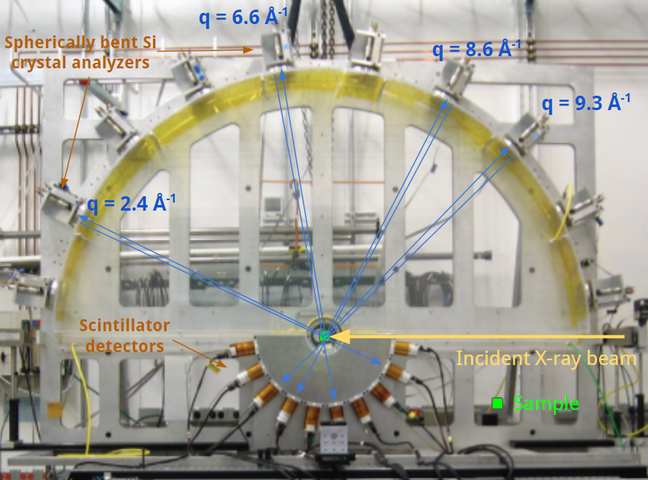

**Solution:** By placing SBCAs at regular intervals designed to reflect radiation that corresponds to a particular wave vector transfer, we are able to effectively manipulate the DDSCS so that we are sensitive to different selection rules depending on the scattering angle.

1. Below is figure 3 from ref [7] which depicts the dynamic structure factor S(**q**,𝜔) as a function of the energy loss for the 18 SBCAs (each of which corresponds to a different q) for La in LaPO4. What change do you observe in spectra as q changes? How does this connect to the conclusion of the previous question?

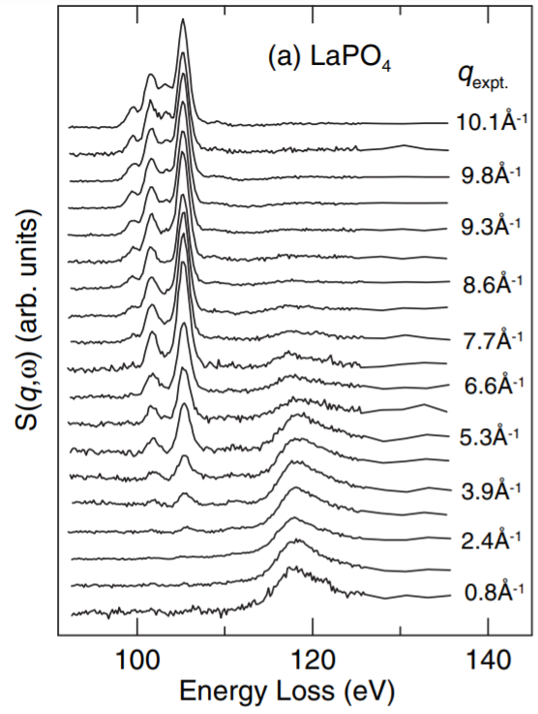

**Solution:** As q increases, the dipole allowed transitions which are present at low momentum transfer begin to turn off. Around 4 a dipole forbidden transition turns at about 15 eV lower than the dipole resonance.

1. The plot below showing the cross section of an inelastic x-ray scattering experiment on Carbon clearly distinguishes between the XRS portion and the contribution from the Compton peak (the valence and core Compton peaks are shown individually as dashed lines). It is clear that to extract high quality XRS data we want there to be minimal overlap between the Compton peak and the binding energy of the shell we are trying to study. Give a qualitative argument for why the Compton peak from the valence shell is so much sharper than the Compton peak front the core (1s) shell. (Hint: Consider the momentum-position uncertainty relationship)

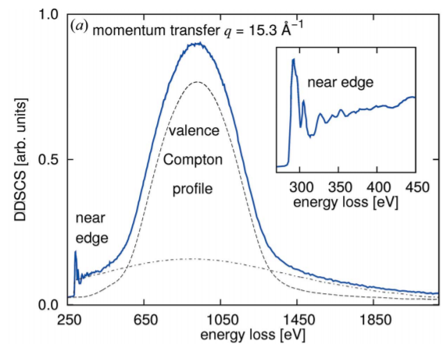

The Compton peak from the core shell is much broader because the momentum distribution of the electrons in this shell are much larger. It is easy to see this when we think in terms of the position-momentum uncertainty relationship. For the valence shell, radial wave vectors are much broader in position space, and therefore we expect there to be a much smaller distribution of momentums, leading to a sharper Compton profile.

1. If the XRS spectra is analogous to XAS in the dipole limit, then in what situation would one be used over the other? What is the tradeoff between them?

XRS is more ideal for studying light elements in a constrained environment (in situ, in operando, high pressure, warm dense matter, ect). This is because it can measure the soft x-ray absorption spectrum, but with the advantage of using hard, well penetrating x-rays. The scattering cross section however is much much smaller than the photoelectric absorption cross section, making it more difficult to get good count rates compared to a standard XAS experiment. Additionally, it is more difficult to get the same resolution with inelastic scattering of hard x-rays than it is with XAS of soft x-rays. (ex: 1 eV resolution at 500 eV vs at 5000 eV)

Citations:

[1] Groot, Frank de, and Akio Kotani. *Core Level Spectroscopy of Solids*. CRC, 2008.

[2] Schülke, Winfried. *Electron Dynamics by Inelastic X-Ray Scattering*. Oxford University Press, 2015.

[3] Sahle, Ch. J., et al. “Planning, Performing and Analyzing X-Ray Raman Scattering Experiments.” *Journal of Synchrotron Radiation*, vol. 22, no. 2, 2015, pp. 400–409., doi:10.1107/s1600577514027581.

[4] Seidler, G. T., et al. “The LERIX User Facility.” *AIP Conference Proceedings*, 2007, doi:10.1063/1.2644702.

[5] Mond, Jesse W. M. Du. “Compton Modified Line Structure and Its Relation to the Electron Theory of Solid Bodies.” *Physical Review*, vol. 33, no. 5, 1929, pp. 643–658., doi:10.1103/physrev.33.643.

[6] Eisenberger, P., and P. M. Platzman. “Compton Scattering of X Rays from Bound Electrons.” *Physical Review A*, vol. 2, no. 2, 1970, pp. 415–423., doi:10.1103/physreva.2.415.

[7] Gordon, R. A., et al. “High Multipole Transitions in NIXS: Valence and Hybridization in 4f Systems.” *EPL (Europhysics Letters)*, vol. 81, no. 2, 2007, p. 26004., doi:10.1209/0295-5075/81/26004.